KENDRIYA VIDYALAYA SANGATHAN
SUMMATIVE ASSESSMENT –I

CLASS: X TIME: 3:00 Hours

SUBJECT: Science MAX. MARKS: 90
-------------------------------------------------------------------------------------------------------------------------
General Instructions:

1. The questions paper comprises of sections A and B, you are to attempt both the sections
2. All questions are compulsory.
3. All questions of section A and section B are to be attempted separately.
4. Question numbers 1 to 3 are one mark questions. These are to be answered in one word
or in one sentence.
5. Question numbers 4 to 6 are two marks questions. These are to be answered inabout 30
Words.
6. Question numbers 7 to 18 are three marks questions. These are to be answered in about 50
words.
7. Question numbers 19 to 24 are five marks questions. These are to be answered in about 70
words.
8. Question numbers 25 to 33 of section B are MCQ based on practical skills and each question carries 1 mark.
9. Question numbers 34 to 36 of section B are questions based on practical skills and each
Questions carries 2 marks each.
10. The question paper contains one value based question.
SECTION-A

1. Why should a magnesium ribbon be cleaned before burning in air?
2. List any two limitations of harnessing wind energy.
3. Name the hormones which help to promote (a) cell division (b) stem elongation
4. What is rancidity? Mention two ways to retard it.
5. Name the physical quantity that determines the rate at which energy is delivered by an
electric current. State and define the unit of this physical quantity.
6. Why is charcoal considered as a better fuel than wood?
7. (a) Differentiate between short circuiting and over loading.
(b) Why should a fuse with defined rating not be replaced by one with a larger rating?
8. Write the chemical formula of bleaching powder. Write a balanced chemical equation
involved in its preparation. Also give two uses.
9. One day Lucky’s mother after taking meal felt pain and irritation in her stomach. His father
was out of station. He was an intelligent boy. He remembered his teacher’s statement and
gave his mother some baking soda solution, which gave relief from pain and irritation of
stomach.
Read the above passage and answer the questions:
(a) Which information given by the teacher helped him to select baking soda?
(b) Suggest any other substance which can be used as a remedy instead of baking soda.
(c) State any two values that you have learned from this passage.

10 (a) Identify the substances that are oxidized and the substances that are reduced in the
following reactions:
(i) CuO + H₂O ------>Cu + H₂O
(ii) Fe₂O₃ + 2Al-------->Al₂O₃ + Fe
(b) What is meant by redox reaction?
11. 2g of ferrous sulphate crystals are heated in a boiling tube
(a) State the colour of ferrous sulphate crystals both before and after heating.
(b)Name the gases produced during heating.
(c) Write the chemical equation for the reaction.
12. Write three points of difference between roasting and calcination.
13. (a) What is meant by saying that the potential difference between two points is 1V?
(b)Find the number of electrons flowing through a circuit, if 1A of current flows through it for 10s.
14. Compare the functioning of alveoli and nephrons with respect to its location, structure and
functioning.
15. Draw a neat and well labelled diagram of human brain.
16. 100j of heat is produced each second in a 4 ohms resistance. Find the potential difference
across the resistor.
17. (a) State Right Hand Thumb rule to find the direction of the magnetic field around a current
carrying straight conductor.
(b) How will the magnetic field be affected on
(i) increasing the current flowing through the conductor ?
(ii) reversing the direction of flow of current in the conductor ?
18. A student has set up a solar cooker in a box by using a black painted aluminium sheet, a
glass sheet and amirror plate. What is the role of each item used in the solar cooker?
19. (a) Name the method used to extract metals of high reactivity.
(b) Name the main ore of mercury. How is mercury obtained from its ore ?
Give a balanced chemical equation.
(c) What is thermite reaction? Explain giving a chemical reaction.
20. (a) Name the gas which is liberated when an acid reacts with a metal. How will you test
the presence of this gas?
(b) What are amphoteric oxides? Give two examples.
(c) Write the chemical equation for the reaction of aluminium metal with
(i) HCl (ii) NaOH
21. (a) Write the three main steps that take place in the chloroplast during photosynthesis.
(b) What are stomata ? Mention its functions.
22. (a) Why are endocrine glands called ductless glands?
(b) Which gland is known as the master gland? Name one hormone secreted by it.
(c) Which hormone is called emergency hormone? Name gland which secretes it.
Why is it called so?
(d) Why is pancreas called a dual gland?
23. (a) A piece of wire of resistance R is cut into five equal parts . These parts are then
connected in parallel. If the equivalent resistance is R’ then what is the ratio of R/R’ .
(b) Give reasons for the following :
(i) Why is series arrangement not used for domestic circuits?
(ii) Why is tungsten used almost exclusively for filament of electric lamps?
(iii) How does the resistance of a wire vary with its area of cross section?
24. (a) A coil of insulated copper wire is connected to a galvanometer. What will happen if
a bar magnet is
(i) pushed into the coil
(ii) withdrawn from inside the coil
(iii) held stationary inside the coils
(b) Name the phenomenon and mention the name of the scientist who discovered it.
State the rule that relates the direction of current in the coil with the direction of
motion of motion of the magnet.

SECTION-B

25. Bottle A contains acetic acid and bottle B contains sodium carbonate solution. When pH paper is dipped in each of the solution, the colour seen in A and B respectively will be
(a) blue , orange (b) orange , green
(c) orange , blue (d) green ,blue
26. A student dissolves some crystals of CuSO₄ in distilled water. The colour of the solutionobtainedwould be :
(a) dark green (b) pale green
(c) blue (d) brown
27. A student adds water to a beaker which contains 5 grams of quick lime . He observes
(a) The beaker becomes cold
(b) The beaker becomes hot
(c) A blue coloured solution is found
(d) A colorless gas is evolved
28. A temporary mount of the leaf epidermal peel which looked pinkish red under the microscope was
(a) Stained in iodine and mounted in glycerine
(b) Stained in iodine and mounted in water
(c)Stained in safranine and mounted in glycerine
(d) stained in safranine and mounted in water
29. A student sets up the apparatus to show that carbondioxide is released during respiration.
After two hours he observes
(a)KOH turns milky
(b)Water level rising in the bent tube in the beaker
(c)Water level decreasing in the bent tube in the beaker
(d)Water turns turbid in the beaker
30. The least count of the ammeter shown below is

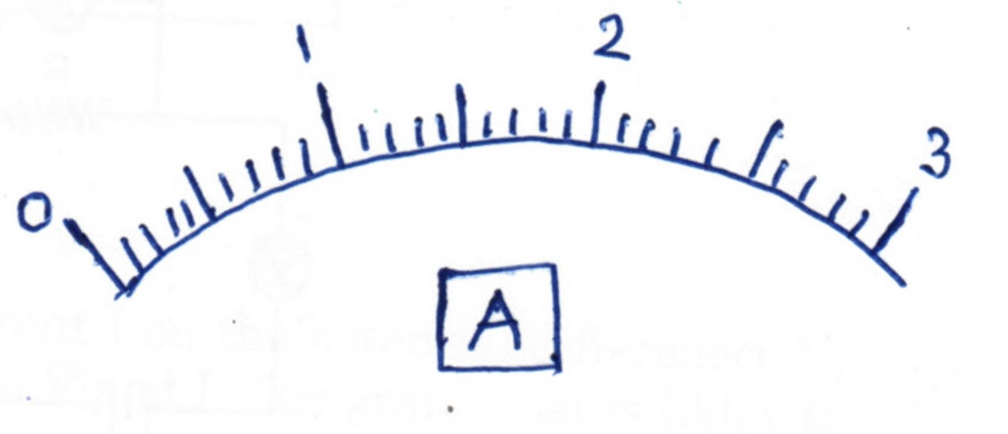

(a) 0.05 A (b) 0.1 A
(c) 0.2 A (d)0.25 A

31. A Student has to connect four cells of 1.5 V each to form a battery of 6 V. He connects the cells in four different ways as shown:

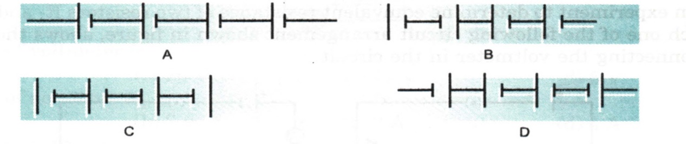

(a) I (b) II (c) III (d) IV

32. Which of the circuit components in the adjoining circuit diagram are connected in parallel?

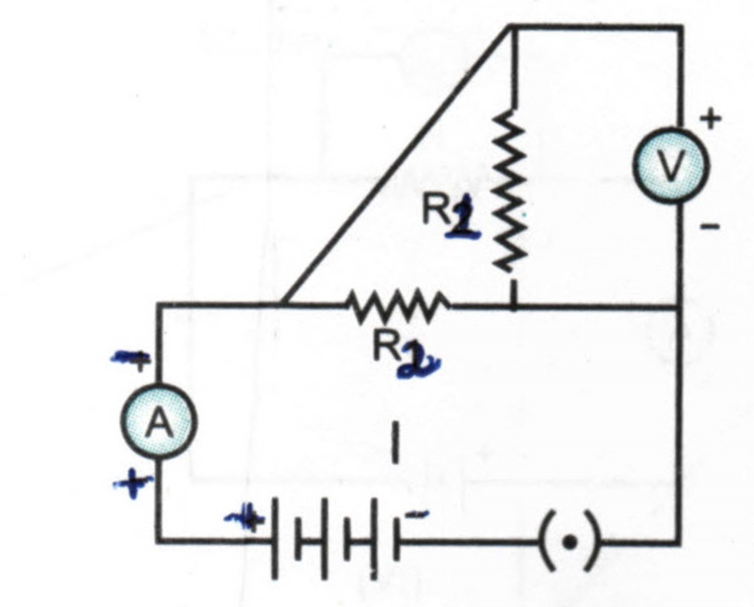

(A) R₁and R2 Only (B) R₂ and V only
(C) R₁ and V only (D) R₁, R₂ and V

33. Basic nature of NaoH solution is due to the presence of
a) oxide ions b) Hydrogen ion c) Hydroxide ions d) sodium ions
34. What is the colour of the precipitate formed when barium chloride is mixed with sodium sulphateSolution? What is this reaction called?
35. (a) The teacher instructed student to place a potted plant in dark for 48 hours prior to an experiment in photosynthesis. Why?
(b) Why do we boil the leaf in alcohol before performing starch test?
36. How are the ammeter and voltmeter connected to the circuit while performing Ohm’s Law?

KENDRIYA VIDYALAYA SANGATHAN
SUMMATIVE ASSESSMENT –I
CLASS: X TIME: 3:00 Hours

SUBJECT: Science MAX. MARKS: 90
-------------------------------------------------------------------------------------------------------------------------
Marking scheme
- To remove the layer of magnesium oxide over it. ( 1marks)
- (i) the setting up of wind energy farm is costly. ( ½ )
(ii) the minimum speed of the wind required is 15 km/h. ( ½ )
- Cell division – cytokinins stem elongation - gibberellins ( ½ + ½ )
- Oxidation of oils and fats resulting in bad smell and taste. (1) Any two reasons.(1/2+1/2)
- Power (1/2) unit – watt (1/2)
Definition of watt (1 marks)
- Charcoal is considered as a better fuel than wood because ( any two points) (1+1)
- Higher calorific value
- Environment friendly fuel
- (a)When a live and neutral wire comes in contact with each other shortcircuiting occurs. (1)
If too many electrical appliances of high power rating are switched at the same time, they draw a
large current from the circuit. This is called overloading. (1)
(b) by doing so the electrical appliances may get damaged in case of accidental flow of current. (1)
8.chemical formula of bleaching powder - CaOCl₂ (1)
Ca(OH)₂ + Cl₂ CaOCl₂+ H₂O (1)
Uses - (i) it is used in the laundries for bleaching clothes.
- To disinfect water. (1/2 + ½)
9. (a) Baking soda acts as an antacid an neutralizes the excessive effect of acids .(1)
(b) milk of magnesia – Mg(OH)₂ (1)
(c) caring, taking right decisions at right time (1)
10. (a)
(i) CuO- reduced
H₂ - oxidized (1/2 +1/2)
(ii) Fe₂O₃ - reduced
Al – Oxidised (1/2 +1/2)
(b) Reaction in which both oxidation and reduction takes place simultaneously. (1)

11. (a) before heating – pale green after heating - brown (1/2 +1/2)
(b) SO₂and SO3 (1/2 +1/2)
(c) 2FeSO₄ Fe₂O₃+ SO₂+ SO₃(1)
12. (1+1+1)
Roasting  - Takes place in sulphide ores  - Heated in the presence of excess of air  - SO₂ is released | Calcination  - Takes place in carbonate ores  - Heated in the absence of air  - CO₂ is released

13. (a) 1V is the potential difference between two points , when one joule of work is done to carry one coulomb of charge from one point to another. (1)
(b) I=1A , t=10s
Q= It
Q=1x10= 10C (1)
No. of electrons (n)=?
Q = ne
n=Q/e = 10/ 1.6 x10⁻¹⁹= 6.25 x 10¹⁹ electrons (1)
14. (1+1+1)
 | Location | Structure | function
Alveoli | Lungs | Sac like | Exchange of gases
Nephrons | Kidneys | Tubular | Filtration of blood

15. Diagram of human brain
Diagram (2) labelling (1)
16. H = 100 j , R = 4Ω , t = 1 s , V = ? (1/2)
H = I²Rt (1/2)
I² = $\frac{H}{Rt}$
$I= \sqrt{\frac{H}{Rt}}$ => $\frac{\sqrt{100}}{\sqrt{4X1}}$ =>$\sqrt{25}$ => 5 A (1)
V = IR
V = 5 X 4 => 20 V (1)
17.(a) right hand thumb rule - (2)
(b) (i) magnetic field will increase (1/2)
(ii) direction of magnetic field will reverse (1/2)
18. blackaluminium sheet and black cooking vessel – absorbs more heat
Glass sheet - increases the greenhouse effect
A mirror – reflects the light into the solar cooker (1+1+1)
19. (a) electrolytic reduction (1)
(b) cinnabar (HgS) , by heat alone (1/2+1/2)
2HgO ^{heat} 2 Hg +O₂ (1)
(c) definition of thermite reaction (1)
Fe₂O₃ + 2 Al Al₂O₃ + Fe (1)
20. (a) hydrogen , burns with a popping sound (1/2+1/2)
(b) Oxides which are both acidic and basic in behavior are called amphoteric oxides (1)
e.gZnO and Al₂O₃ (1/2 +1/2)
2Al + 2HCl 2 AlCl₃+ H₂ (1)
2Al + 2 NaOH 2 NaAlO₂ + H₂ (1)
21. (a)
(i) absorption of light energy by chlorophyll.
(ii) conversion of light energy into chemical energy and splitting of water molecule.
(iii)Reduction of CO₂ to carbohydrates .( 1+1+1)
(b) Definition of stomata (1)
Function (1)
22. (a) As they do not have any ducts to pour their secretions. They directly pour them into the blood. (1)
(b) Pituitary gland , growth hormone (1/2+ ½)
(c) adrenaline , adrenal gland (1/2+ ½)
It is called emergency hormone because it helps us to deal with emotions like stress, joy, grief excitement etc (1)
(d) because it secretes both enzymes and hormones (1)
23.(a) Resistance - R (2)
When cut into five parts , each part is $\frac{R}{5}$
Equivalent resistance in parallel
$\frac{1}{R^{'}}=\frac{1}{R/5}+\frac{1}{R/5}+\frac{1}{R/5}+\frac{1}{R/5}+\frac{1}{R/5}$
$\frac{1}{R^{'}}=\frac{5}{R}+\frac{5}{R}+\frac{5}{R}+\frac{5}{R}+\frac{5}{R}$
$\frac{1}{R^{'}}=\frac{25}{R}$
$R^{'}=\frac{R}{25}$
$\frac{R}{R^{'}}=\frac{R}{R/25}$ = 25
(b) (i) appropriate reason (1)
(ii) appropriate reason (1)
(iii) R α $\frac{l}{A}$ (1)
24. (a)
(i) deflection is seen in the galvanometer.(1)
(ii) this time deflection is seen in the direction opposite to the previous one. (1)
(iii) No deflection in the needle is seen. (1)
(b) Electromagnetic induction (1/2) Michael faraday (1/2)
, state flemming right hand rule (1)
SECTION B
25. (c) orange , blue
26. (c) blue
27. (b) the beaker becomes hot
28. (c) stained in safranine and mounted in glycerine
29. (b) water level rising in the bent tube in the beaker
30. (b) 0.1 A
31. (a)
32. (d) R₁ ,R₂ and V
33. c) Hydroxide ion
34. white (1) double displacement or precipitation reaction. (1)
35. (a) to destarch the potted plant (1)
(b) to make the leaf colourless so that starch test can be seen easily. (1)
36. ammeter - series (1)
Voltmeter - parallel (1)

