SA 1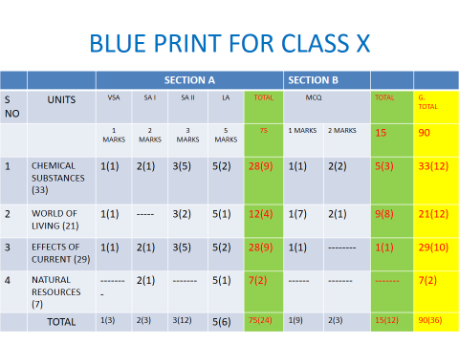

SUMMATIVE ASSESSMENT –I (2016-17)
Subject- Science
CLASS-X
Time :- 3Hrs 30 min. Maximum Marks 90
General Instructions:
1.The question paper comprises of two sections A and B .You are to attempt both the section.
2. All questions are compulsory.
3. There is no overall choice. However, internal choice has been provided in all the five questions of five marks category. Only one option in each question is to be attempted.
4. All questions of section A and all questions of section B are to be attempted separately.
5. Question No. 1 to 3 in section A are one mark question. These are to be attempted separately.
6. Question No. 4 to 7 are two marks question, to be answered in about 30 words each.
7. Question No. 8 to 19 are three marks question. To be answered in about 50 words each.
8. Question No.20 to 24 are five marks questions. To be answered in about 70 words each.
9. Question No.25 to 42 in section B are multiple choice based on practical skills. Each question is a one mark question. You are to choose one most appropriate response out of the four provided to you.
10. An additional 15 minutes time has been allotted to read this question paper only and will not write any answer script during the period.
Section –A
- Give an example of a metal which can be cut with knife.
- Write a balance equation to represent the following reaction:-Aluminum reacts with copper chloride to give aluminum chloride and copper.
- State and define the unit of current.
- Name the respiratory organs of (a) Fish (b) Mosquito (c) Earthworm (d) Dogs
- Surface of some metals loose their brightness when they kept in air for a long time. Why?
- The atomic no. of sodium is 11, fluorine is 9 and Neon is 10. Why are sodium and fluorine very reactive while Nein show almost no reactivity?
- Although bile juice has no digestive enzyme. It is still considered to be very important for digestion of food .Give two reasons.
- Define neutralization reactions. Give an example in daily life application .
- Describe an activity to show that acid produce ions only in aqueous solution.
- What is osmoregulation? How does it takes place in human beings ?
- Define phototropism. Which hormone is responsible for it . How?
- Calculate the number of electrons that will constitute a flow of charge 5 C.( charge of one electron is 1.6*10⁻¹⁹C.
- what is bio gas? How is it produced . Mention one feature of bio gas that make it an ideal fuel.
- classify the following reaction into different types-
AgNO3 +NaCl(aq) ->AgCl(s) +NaNO3(aq)
CaO(s) +H2O->Ca(OH)2
2KClO3(s) -> 2KCl+3O2
(b) which of the above reaction is/are precipitation reaction ? why is the reaction called precipitation reaction?
15. When water is added to a white powder ‘A’ vigorous reaction takes place & a large amount of heat is released. ‘A’ is also used for white washing.
(a). identify the ‘A’
(b)give the balanced equation.
c )give the name and formula of the product.
16.Apiece of wire having resistance R is cut into four equal parts –
(a) How does the resistance of each part compared with the original resistance.
(b) If four parts are joined together in parallel , how will resistance of combination with the resistance of original wire ?
17 .What is meant by the term of magnetic field lines ?list any two properties of field lines.
18 .An electric room heater is rated at 2KW .calculate the cost of using it for 2 Hrs. daily for the month of September ,if each unit cost is 4 Rupees.
19. Mention the name of secretory part / gland and function of following hormones.-
(a) Insulin
(b) Progesterone
( c )Oxytocin
20. A person has lost his control over muscular activities.
a) What can be the possible cause?
b) What would you advice the person to overcome the problem?
c) Which value is inculcated?
21.(a) Give two example of renewable & non- renewable energy sources.
(b) Why is there need for harnessing non-conventional sources of energy.
( c ) Write the name of eco-friendly energy sources.
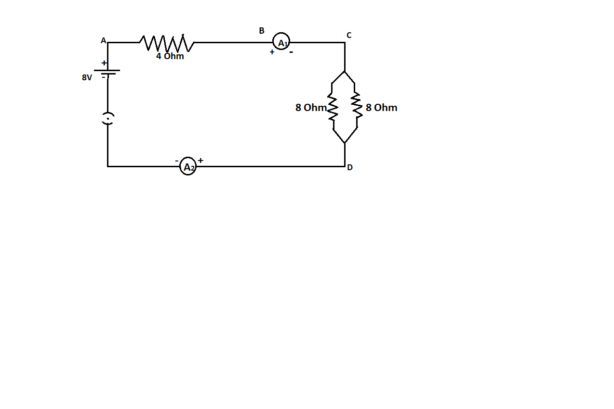
22. Find out the following in the electric circuit given in the figure-(a) Potential difference across 4 ohm resistance

(b) Difference in ammeter reading if any of A1 & A2
23. ( a) Explain inn brief the mechanism of circulation of blood circulation of blood in human body.
(b) Lymph is another type of fluid involved in transportation. Justify the statement by two reason.
OR
Explain the excretory system in human beings.(see fig.6.13 page no.110 NCERT textbook)
List any two strategies used by plants for excretion.
24. Account for the following –
(a) melting point of ionic compounds are high
(b) Aluminum is more active then iron yet there is less erosion of aluminium when boith are exposed to air.
( c )Solder is used for welding electricals wires together
(d ) a sulphide ore is converted into its oxide to extract the metal .
(e) turnished copper vessels are cleaned with tamarind juice.
OR
Write balanced chemical equation for reaction taking place when –
Zinc carbonate is calcinated
Zinc sulphide is roasted
Zinc oxide is reduced to zinc

Cinnabar is heated in air

Manganese dioxide is heated with aluminum powder

25. Bottle A contain acetic acid and bottle B contain sodium carbonate solution. When pH paper is dipped in each of the solution, the colour seen in A and B respectively will be:

a) blue, orange b) orange, green

c) orange, blue d) green ,blue

SECTION :-B

26. On putting of few drops of a liquid on pH strip the colourofpH strips change to green , the liquid is most probably

(a) Lemon juice3 (b) Dilute HCl

(c) NaOH solution (d) Water

27. Colourless gas is liberated when HCl acid is added to a solution of washing soda, the name of gas is

(a) Carbon di oxide (b) Nitrogen di oxide

(c) Sulphur di oxide (d) Sulphur tri oxide

28. The colour of metal deposited when iron nails are dipped in aqueous solution of copper sulphate is (a)reddishbrowen (b) Green

(c) Grey (d) Silvery white

N22229

29. What is the least count of following voltmeter

(a) 0.5 volt (b) 0.1 volt

(c) 0.05 volt (d) 0.005 volt

30. A solution of ammonium chloride is

(a) Acidic (b) Basic

(c) Neutral (d) Amphoteric

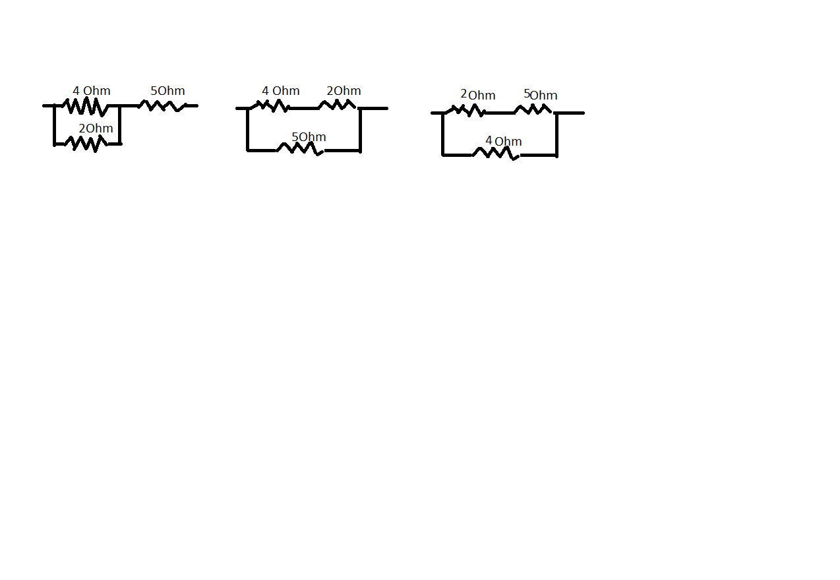
31. The equivalent resistance of 4 ohm, 5 ohm ,2 ohm, is 6.33 ohm. Then how can they be connected z

X b) Y c) Z (D) None of these

32. In given circuit voltmeter reading will be 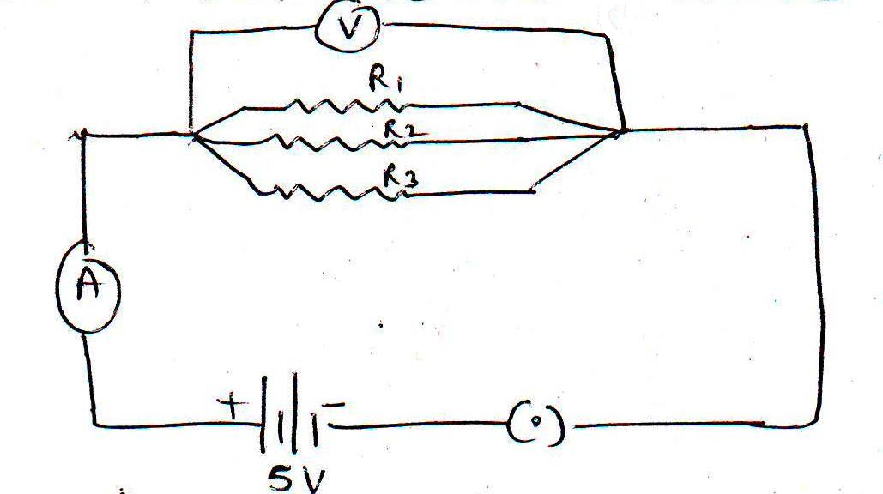

0 volt (b) 5 volt (c) 1 volt (d) 2 volt

33. The oxygen evolved during photosyntheciscome from

(a) Spliting of carbon di oxide (b) From air

(c) Splitting of water (d) None of above

34. Before the testing of leaf for starch at end of experiment light is necessary for photosynthesis , the experimental leaf should br boiled in

(a) water (b) alcohol

(c) KOH solution (d) HCl solution

35. IN the experiment demonstrating respiration in germinationg seeds, KOH is used to

(a)absorb CO₂ produced by the seeds

(b) Absorb O₂present in flask

(c) Absorb H2O vapour released by the seed

(d) Liberate O2 to be used by the seed

36. For the experiments “ light is necessary for photosynthesis” the potted plant was first kept in darkness for a day this is to

(a) deactivate chloroplast (b) destarch leaves

(c) activate chloroplast (d) prepare leaves for photosynthesis

37. Which of the following part of the leaf will become blue black after the treatment of iodine solution

(a) uncovered part of leaf (b) Covered part of leaf

(c) Both of these (d) None of these

38. The opening and closing of stomata are connected with the

(a) Intinsity of light (b) Turger pressure

(c) loss of water (d) all of these

39. In the circuit below the voltmeter and ammeter reading would be recpectively

(a) 0 volt and 0 Ampere each (b)2 V and 5A each

(c) 2V and 2A (d) 2 V and 0.8A

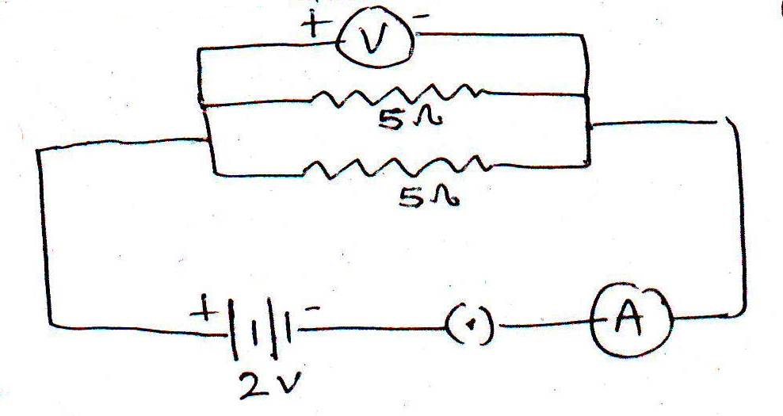

40. which of the following in figure of open stomata of monocot plant

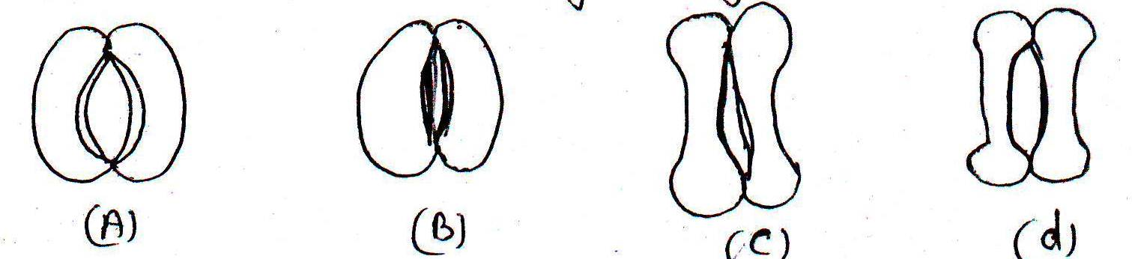

A (b) B (c) C (d) D

41. A rheostat is connected in circuit to

(a) Provide fixed resistance in circuit

(b) Stop current in circuit

(c) Provide safe path to current

(d) Increase or decrease current in the circuit

42. While preparing a temporary stained mount of a leaf epidermal peel, the extra strain is removed by :

a) Washing with water

b) Washing with alcohol

c) Soaking with filter paper

d) Absorbing with cotton

MODEL ANSWERS - (SA1)

Section –A

1. Sodium(Na)

2.2Al +3Cucl₂ 2AlCl₃ + 3Cu

3. Ampere, if 1C of charge flows in 1second then current is said to be 1A.

4. (1) gills (2) Trachea (3) Skin (4) lungs

5. This is due to formation of undesirable compound such as oxides, Sulphide, Carbonates on the surface of metals due interaction with air & moisture.

6. Na=2,8,1Ne=2,8 F=2,7

Sodium Na & fluorine F have tendency to lose or gain electrons to complete their

Octet.Where as Ne has its Octet complete and is extra stable

7. (1) Bile juice helps in to emulsify fat.

(2) Due to basic nature it neutralizes the acidic traces reaching the small intestine.

8. Reaction between acid & base gives salts & water and release energy that is

Neutralization.

Reaction: HCl + NaOHH₂O + NaCl + Energy

Antacid (Mg(OH)₂) is used to cure acidity in stomach.

9. Heat a pinch of NaCl with con.H₂SO₄ in a test tube. Pass HCl gas on dry blue

Litmus paper no change in colour takes place. Now pass HCl through blue litmus solution it turns red. This is because in aqueous solution H⁺ ions produced.

10. Balance the water & salt level in body is called osmoregulation. It takes place nephron by the ADH (anti diuretic hormone). It effects the permeability of cells of nephron for absorption of water.

11. The growth movement of plants induced by stimulus of light is called phototropism.

Auxins hormone is responsible for it.High amount of Auxins is present in shady or dark half region of shoot apex which causes high growth & turns the plant towards light source.

12. 1electron=1.6*10⁻¹⁹C

1C=1/ 1.6*10⁻¹⁹

5C=5/ 1.6*10⁻¹⁹

=3.12**10⁻¹⁹

13.The fuel gas produced by the animals & plant waste is called bio gas which contains methane. It is non polluting& has high calorific value.

14. (a) 1. Double displacement reaction

2. Combination reaction

3. Decomposition reaction

(b) Double displacement reaction is a precipitation reaction because in this

Reaction one insoluble product settles down at the bottom of test tube& get

Separated from soluble product.

15. A is calcium oxide CaO

CaO +H2O---Ca (OH)₂

16. (a) Resistance of a wire is proportional to its length. Therefore cut into four

pieces, resistance of each pieces will be R/4.

(b) When 4 pieces each of resistance R/4 are connected parallel, the combined

Resistance will be R’

1/R’=1/R/4+1/R/4+1/R/4+ 1/R/4

1/R’=4/R+4/R+4/R+4/R

1/R’=16/R

R’=R/16

17. Intensity of magnetic field around a bar magnet is shown by lines that are called

Magnetic field lines.

1. They emerge from north pole& enter S pole

2. Two magnetic lines of force never intersect each other

18. P=2KW=2000W t=60Hrs September=30days

Energy Units consumed= P*T/1000

=2000*60/1000=120KWH/Unit

Total Cost=120*4=480Rs.

19 (1) Insulin –beta cells of pancreas, control sugar level

(2) Progesterone – carpus leutium of ovary, maintains pregency& fixes the embryo

touterus wall.

(3)Oxytocin –Pitiutary gland, milk secretion, birth hormone

20.a)Cerbellum control is lost due to taking of excess of alcohol

b) Advice – Not to take alcohol

c) Value- concern for human life

21.a) Renewable –wind , solar energy

Non Renewable –coal, petroleum, natural gas

b) Sources of fossils are limited & will exhausted with in few decade and

rapid growth of population is increasing demand of more energy.

c) Solar energy

22. a) Total R=4+4=8 ohm V=8volt

I=V/R=8/8

=1A

Potential difference across 4ohm=V’=IR

V’=1*4=4V

b) No,There is no difference in ammeter reading of A₁ and A₂because both are in

Serie.
23. A )

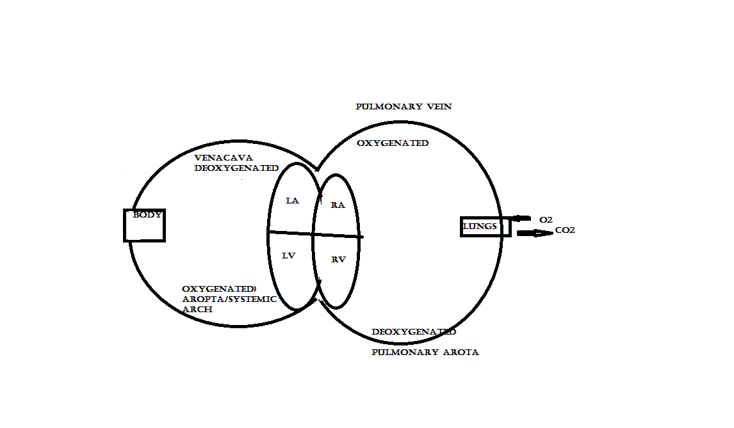

b)1. It drains tissue fluid from the extra cellular space back into blood.

2. it takes lymphocytes and antibodies from the lymph nodes to the blood.

3. Some of the fluid from digestive tract is absorbed in the lymph and store the fluid

Temporarily.

OR

DIAGRAM OF EXCRETORY SYSTEM

B) 1. Transpiration

2. Bark formation

3. Stomata (gas exchange)

24. A) due to presence of strong electrostatic force of attraction between ions

B) This is due to the formation of thin protective oxide layer on the surface of

Aluminum but in case of iron the oxide layer peels off exposing fresh surface to

Corrosion.

C) Because it has low melting point

D) This because oxide can be reduced easily.

E) Because the carbonate layer dissolves in tamarind juice.

OR

ZnCO₃ calcination---------- >ZnO + CO₂

2ZnS + 3O2roasting---------- >2ZnO +2 SO₂

ZnO + C heating---------- > Zn + CO

2 HgS 3 O₂ heat---------- > 2HgO + 2 SO₂

3 MnO₂ + 4 Alheat---------- > 3 Mn + 2Al₂O3

SECTION –B

25. C

26. A (Lemon juice)

27. A (CO₂₎

28. A (reddish brown)

29. B (0.1V)

30. A (acidic)

31. A (X)

32. B (5V)

33. C (splitting of water)

34. B (alcohol)

35. A (absorb CO₂by seed)

36. A (deactivate chloroplast)

37. A (uncovered part)

38. D (all these)

39. D (21V &0.8A)

40. D (d)

41. D (increase or decrease current in circuit)

